**Ben Ghirardani PDA**

**Unit Analysis & Design**

A & D 1 - A Use Case Diagram

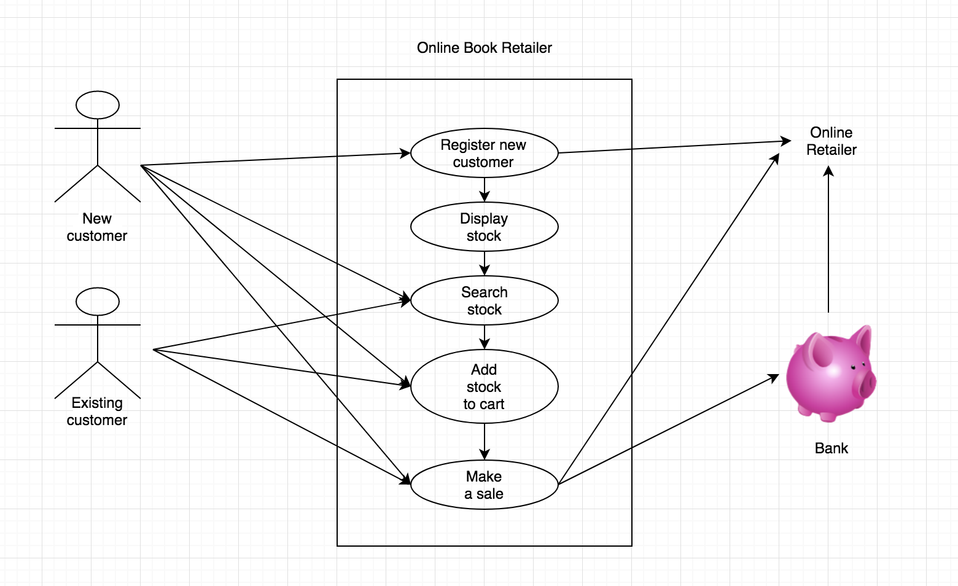

A & D 2 - A Class Diagram

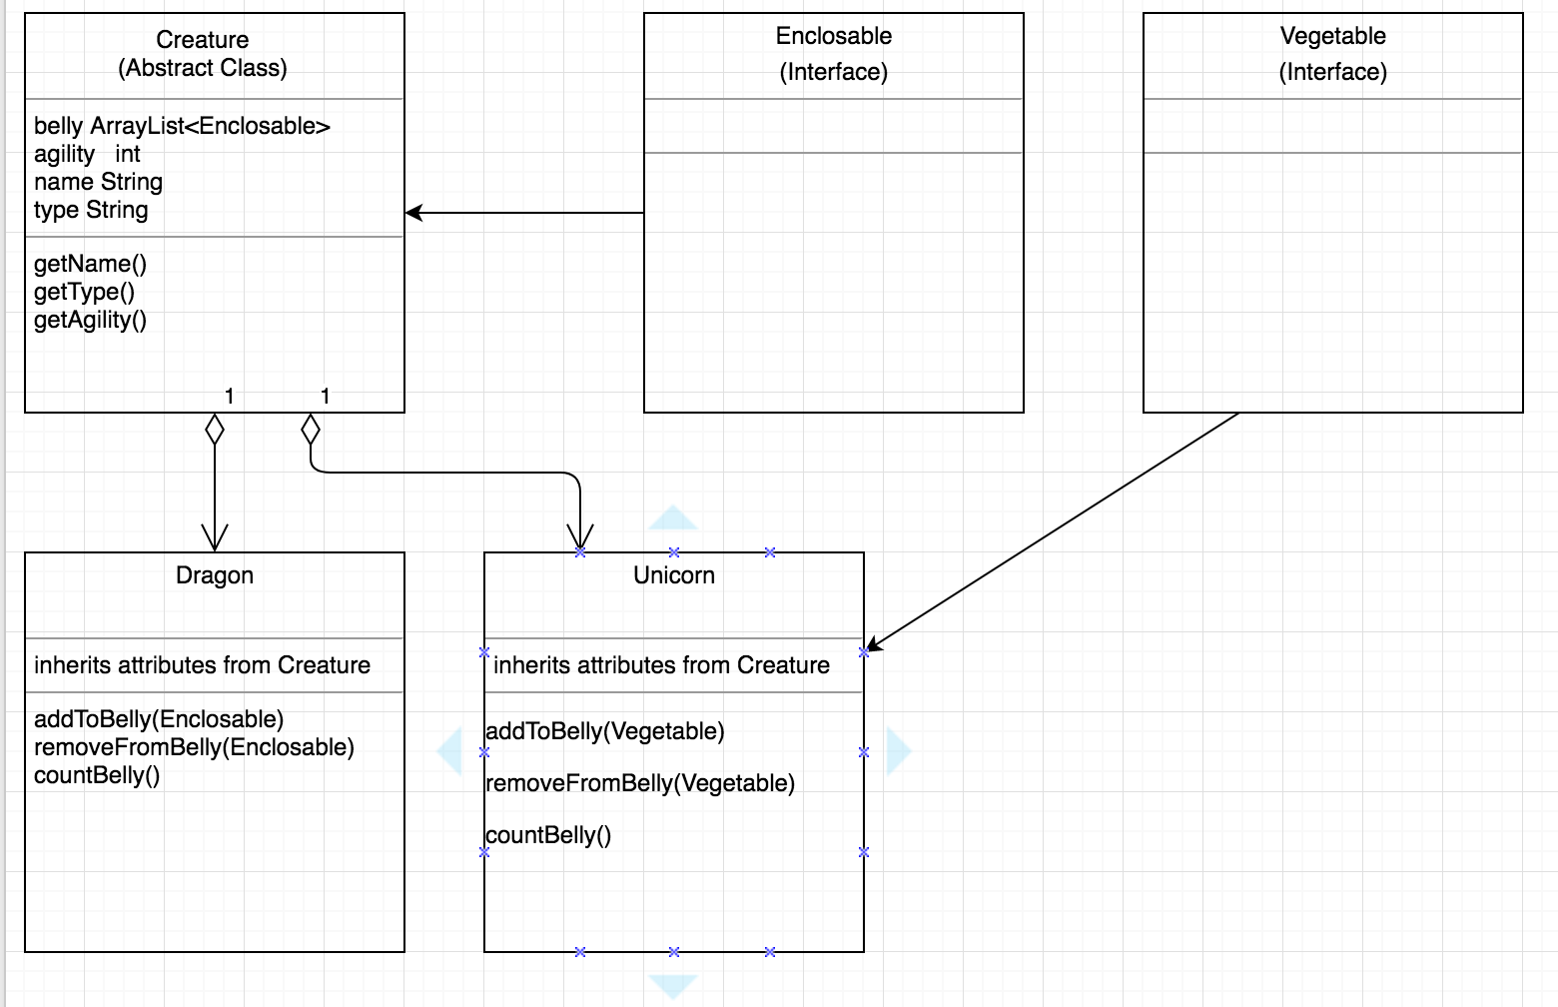

A & D 3 - An Object Diagram

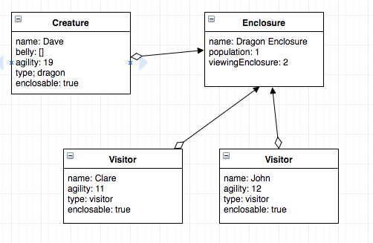

A & D 4 - An Activity Diagram

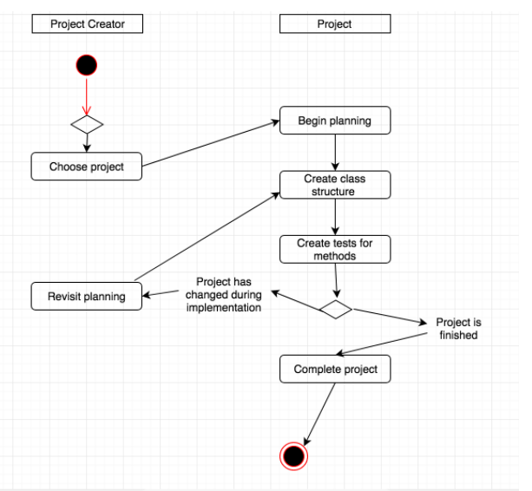

A & D 6 - Produce an Implementations Constraints plan detailing the following factors:

Plan for record store stock keeping app.

|  |  |  |
| --- | --- | --- |
| **Constraint** | **Possible Effect of Constraint on Product** | **Solution** |
| 1. Hardware and software platforms | App is designed only for desktop/laptop screens, would not work on a mobile phone screen. | Redesign app to function on a mobile screen. |
| 2) Performance requirements | Large amount of stock saved to database could slow search down. | Remodel database relationships to be more efficient using less computing power to run. |
| 3) Persistent storage and transactions | App requires storage of stock to be persistent. Without this it is pointless. | Create backup of data. Prevent easy deletion of data, ie. “are you sure?” rather than instant delete on button press. |
| 4) Usability | Colour scheme needs to account for colourblind users. Some users will use screen readers. | Provide option to customize colour schemes for colourblind users. Provide semantic HTML for screen readers. |
| 5) Budgets | Large amounts of data could incur high costs for server space. | Invest in cloud solution that scales quickly with requirements. |
| 6) Time | Product is required immediately for stock keeping. | Provide early prototype and iterate quickly via updates. |

1. This constraint is an issue because the number of people accessing content on a mobile device is increasing dramatically each year. From a user’s perspective the inability to access (or a poor experience) via mobile device may cause them not to engage with the product, meaning a loss of a potential customer / user. From a business perspective this affects not just revenue, but reach and growth of users. This lack of accessibility could end a project before it has a chance to make any impact.
2. This performance issue could have a similar impact to a lack of accessibility. If performance is poor, a user may be compelled to use a rival product. From a business perspective a reputation for producing poorly performing products could have a long term impact in terms of the wider opinion of future products too.
3. This is a core requirement for the product, without which a user’s experience would not fit the minimum requirements for such a product. From a business perspective this would be a core requirement and likely something that would be focused on very early in development.
4. From a user perspective, although colourblind users are a minority of users, it is reported that 8% of men (although only 0.5% of women) are colourblind. This can still add up to a significant number of potential users. A product/company that accounts for this is likely to create a certain amount of goodwill from users appreciative that displays take their sight into account. A business that takes into account as many ‘small gains’ as possible such as creating products suitable for people who are colourblind or people who use screen readers will have a bigger potential market than those that don’t. Also, it’s just a nice thing to do.
5. This a big concern from a business perspective. If a solution isn’t found to scale the data storage with the number of users, a situation could occur where storage cannot cope with user needs. Conversely, a solution that overestimates storage needs early on and doesn’t scale could incur significant costs that a new company cannot sustain.
6. This constraint is at the core of agile development. From a business perspective the ability iterate quickly from early on in the development lifecycle allows a business to gather data on a product and not spend time and resources on something that isn’t going to make an impact in its market.

A & D 5 - An Inheritance Diagram

